EXPERIMENT NO 11

Determination and plotting of Magnetic Flux density in Ferromagnetic Materials with different (i) length, (ii) width and (iii) magnetic field intensity.

Aim:
To write program for Magnetic flux density in ferromagnetic materials using SCILAB.

Software required:
•SCILAB version 6.0.1

Program:

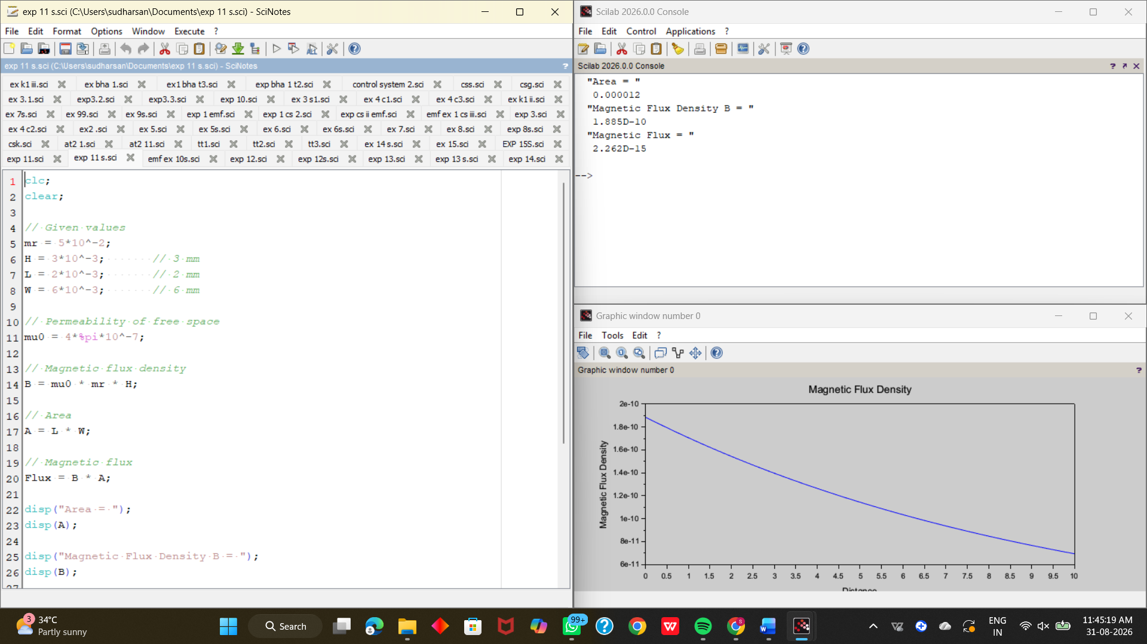

Output:



Theoretical calculations:

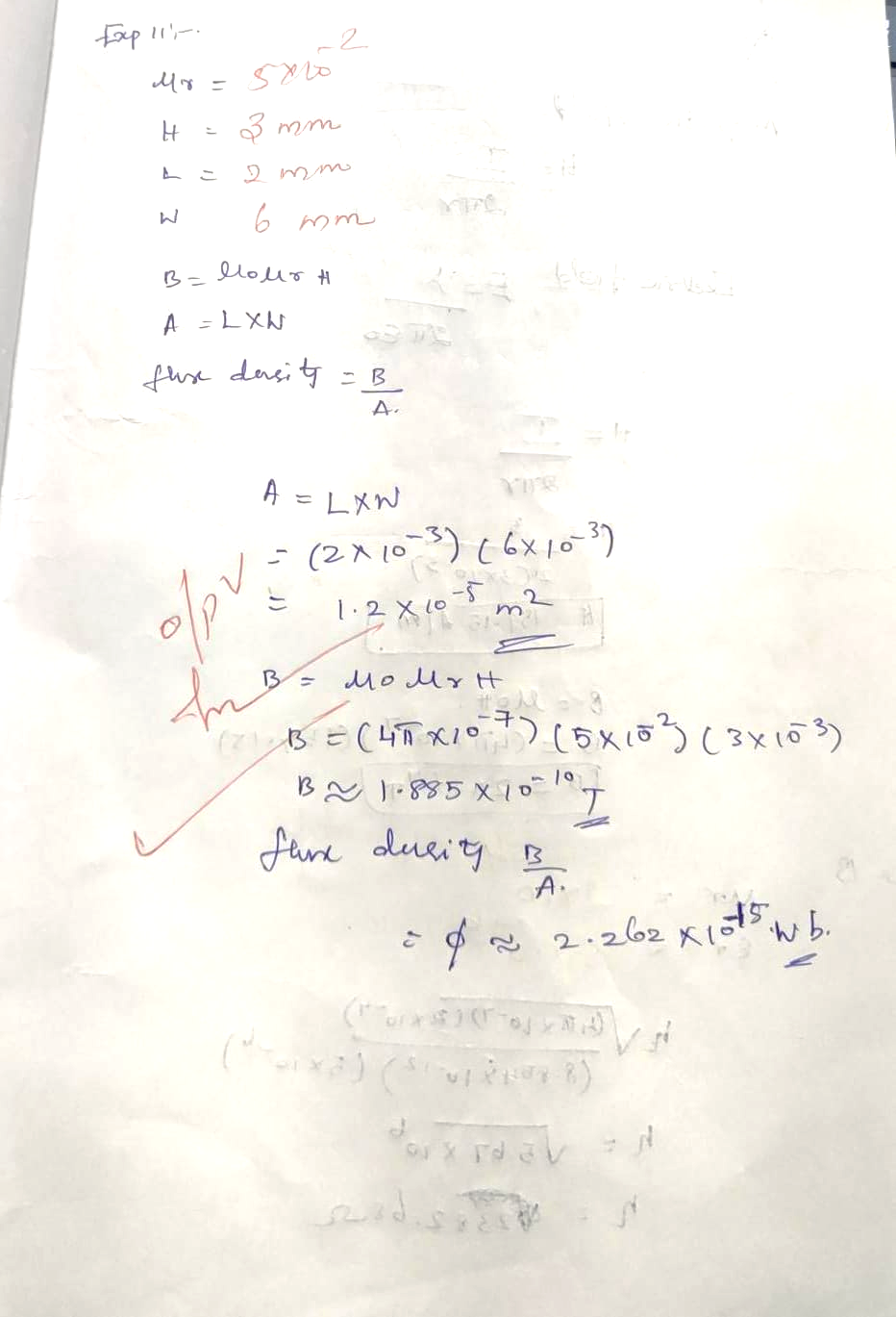
Case 1: Examine the effect of length of a ferromagnetic material on the magnetic flux density (B).

Analytical :
Calculate the magnetic flux density for the following conditions
- The material is ferromagnetic with relative permeability (μr) of 500.
- The magnetic field intensity (H) is held constant at 100 A/m.
- The length of the material varies from 0.1 m to 2 m.

Program:
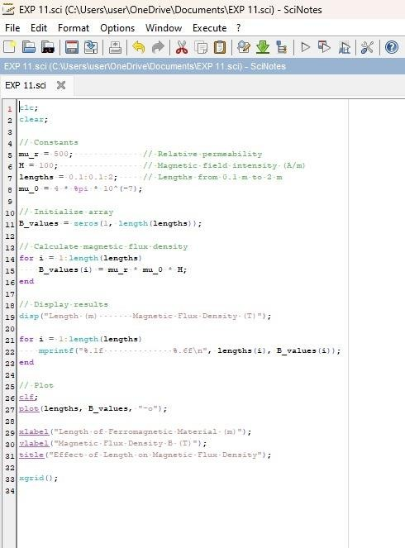

Output:

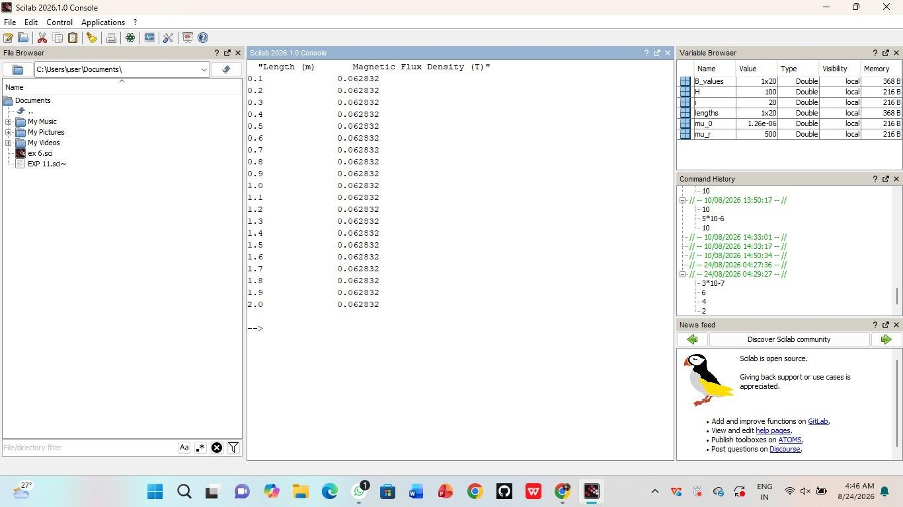

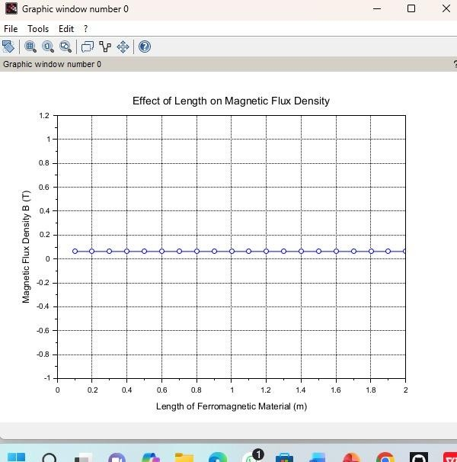
Case 2: To investigate how the magnetic flux density (B) in a ferromagnetic material changes with
Different widths at a constant length and magnetic field intensity.

Analytical:
Calculate magnetic flux density (B) in a ferromagnetic material changes with different widths at a constant length
And magnetic field intensity for the following condtions
- Material: Soft iron (same as in Case Study 1)
- Length (L): Constant at 10 cm
- Magnetic Field Intensity (H): Constant at 1000 A/m
- Width (W): Varies from 2 cm to 10 cm (i.e., 2 cm, 4 cm, 6 cm, 8 cm,
10 cm)

Program:
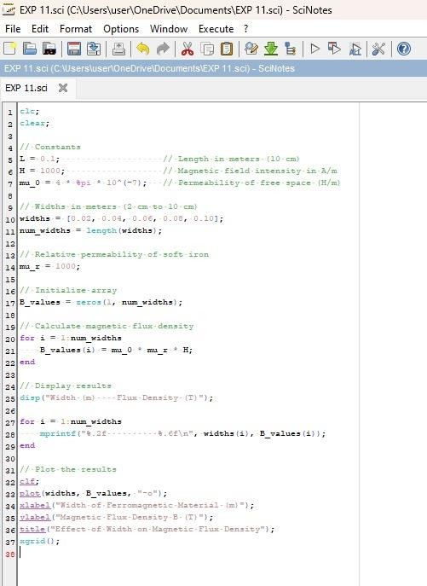

Output:

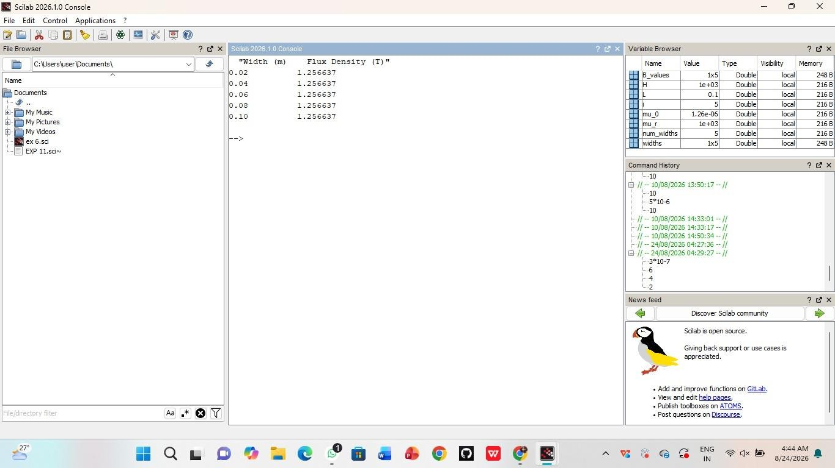


Case 3: To examine how the magnetic flux density (B) in a ferromagnetic material change with different values of magnetic field intensity at constant length and width.

Program:
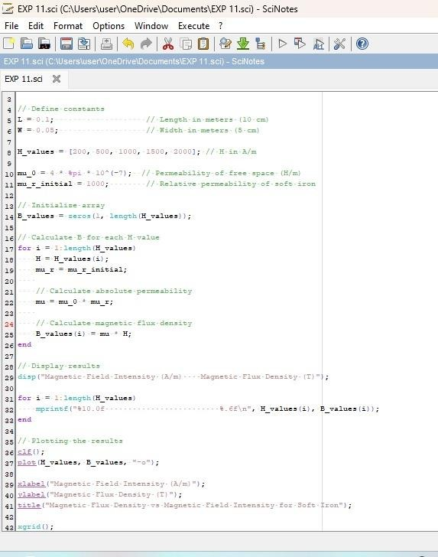

Output:
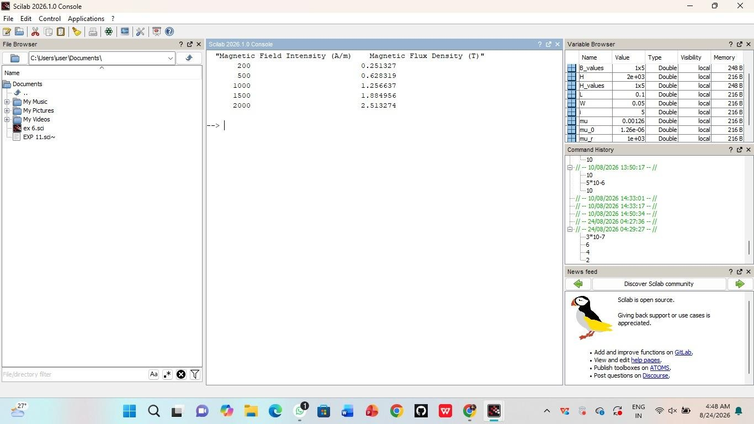

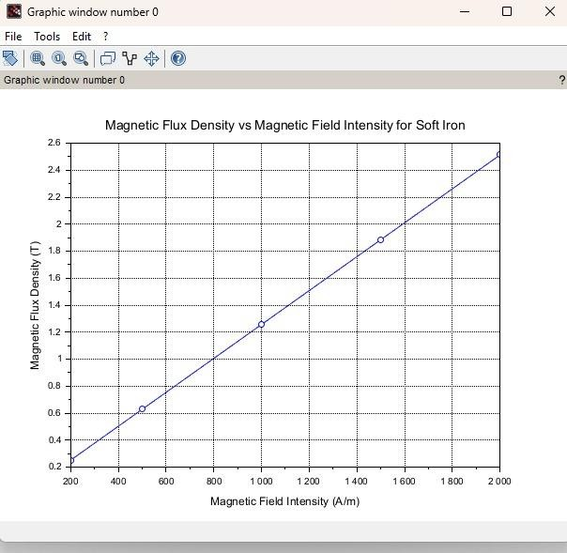

Result:
The effect of Magnetic field intensity of a ferromagnetic material on the magnetic flux density (B) is examined.

